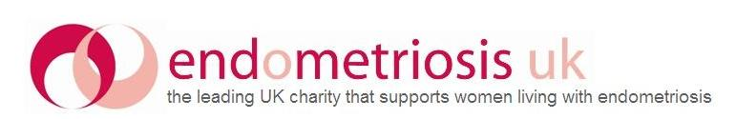

Support Network Manager Job Description and Person Specification
Main Responsibilities
Management of Support Network
- Planning and monitoring of support services
- Liaising with and managing group leader, helpline, online group leader and HealthUnlocked moderator volunteers
- Responding to volunteer emails, phone calls and requests
- Overseeing and monitoring helpline provision
- Managing issues with helpline – eg repeat callers/ helpline numbers
- Management of helpline statistics volunteer
- Collation of monthly helpline statistics
- Overseeing support group provision
- Collation of group leader statistics (survey monkey collates this and is chased by SNO). Quarterly monitoring of numbers of groups taking place
- Managing “Volunteer’s Week” campaigns
- Volunteer supervision
Recruitment and Training of volunteers
- Planning volunteering recruitment in response to needs of service and organization, including:
  - Setting recruitment timelines
  - Advertising and generating applications
  - Reviewing volunteer applications
  - Phone interviews with prospective volunteers and making subsequent decisions
- Monitoring, development and updating training package
- Preparing training resources and organising training events
- Facilitating training
Event Organisation
- Sourcing and organising of venue
- Sourcing and organising speakers
- Catering requests
- Technical requests
- Creation of information for public
- Copy for website/ newsletter publicity
Reporting
- Providing information as required by the organization eg for annual report
- Statistics for Support Network
- Statistics for funding bids
Admin
- Managing Support Network Officer
- Creating and updating volunteer policies
- Maintaining support network and volunteer information on CiviCRM database and other records
- Updates to support network manual
- General email correspondence
- Contributing to social media management
- Managing and engaging with media enquiries where needed and appropriate
General
- Other activities as reasonably requested by your line manager
- Endometriosis UK is a small charity, and all staff support the general running of the organisation in addition to their specific role activities

Person Specification

Essential Attributes
Experience:
- Working with and supporting frontline volunteers
- Coordination and delivery of training
- Project management
- Line management
Skills:
- Computer literate, including with databases
- Good communication skills
- Methodical and organised
- Patient and empathetic
- Flexibility and adaptability to change
Knowledge
- Of the NHS and health policies
Qualifications
- Degree or equivalent standard of education
Other
- Self motivated and willing to be a proactive member of a small team (please note that at times you may be the only staff member in the office)

Desirable Attributes:
Experience:
- Working within a health-based charity
- Experience of running a Helpline
Skills
- Online forum moderation
- Website literacy
Knowledge
- Understanding about endometriosis
Qualifications
- Qualification (or evidence of courses) in volunteer management

